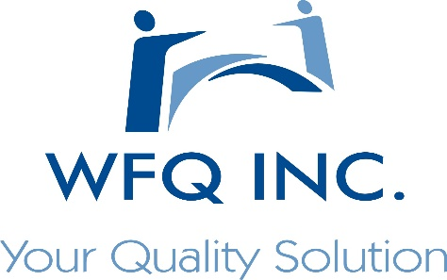
WFQ Inc. Staffing Services

Information Technology Solutions
What We Do

The core business that WFQ Inc. was founded upon is skilled trade and general labor staffing. Since its inception WFQ Inc. has provided quality employees for customers in every industry including manufacturing facilities, food production plants, catering events, restoration projects and more

We are experienced in high-volume general labor accounts to specific trade positions, WFQ Inc. Screens all employees for qualifications, conducts national background checks and drug test for every employee we place by running extensive orientations and training sessions, WFQ Inc. Provides reliable labor at an affordable cost.

Orientation and Training

WFQ Inc’s orientation sessions are specifically tailored to the policies and regulations of our individual customers utilizing video, print literature and our employee handbook.

WFQ Inc. provides training sessions tailored to optimize efficiency and maximize safety, specifically in the skilled trade labor that may prove hazardous without proper instruction. A WFQ Inc. placements are trained in proper techniques of their job function regardless of experience.

Aside from math and logic testing, WFQ Inc. also provides specialized testing on specific functions such as reading multimeters, calipers, and gages identifying product deficiencies, and conflict resolution questions tests to insure we are providing a qualified and reliable employee to our customers

A Woman Owned Minority Company
Addressing the Staffing needs of the Southeast Michigan Marketplace
WOSB Certified
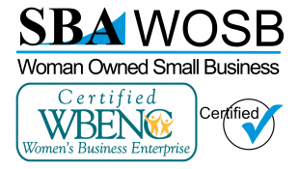 ISO 9001:2015 Certified 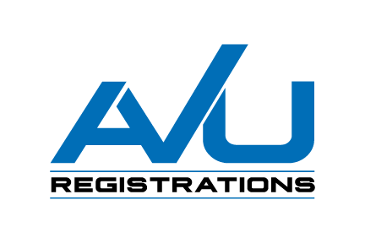
Staffing Capabilities

General Labor
- Manufacturing line workers
- Hotel housekeeping personnel
- Catering event staff
- Landscaping workers
- Packaging personnel
- Warehouse personnel
- Janitorial

Skilled Trades
- Machine operators
- Tool and Die
- CNC Operators
- CMM Operators
- Maintenance Techs

Clerical
- Reception
- Bookkeeping
- Word Processing
- Data Entry
- Record keeping
- Filing

Manufacturing Management
- Quality Engineering
- Production Management
- Materials Management
- Production Line Supervisors
- Process Engineers

Professional
- Office Management
- Sales personnel

Our Staff

With an entire division of recruiters, account managers and site managers, WFQ Inc. works around the clock to provide essential staffing and resources that are devoted to our customer base filling our orders while producing employees that will exceed our expectation.

Options

We offer various creative options for temporary placements, temp to hire, contract and direct hire positions

Talk to Us

WFQ Inc. is fully equipped to handle any skilled or general labor needs with little or no lead time. Please contact us today and lets talk about your employment needs.

WFQ Inc. For more information on Staffing Services www.wfqinc.com

5751 South Sheldon Road contact our Staffing Specialists sales@wfqinc.com
Canton MI, 48188 (734) 548-8313

